Activity No . 2
Aim : Familiarization with Transmission media and Tools Coaxial cable , Fibre Optic Cable ,Twisted pair cable, Connectors etc.
Requirements:
Coaxial cable , Fibre Optic Cable ,Twisted pair cable, Connectors etc.
Procedure:
Transmission Medium:
A communication channel that is used to carry the data from one transmitter to the receiver through the electromagnetic signals .The main function of this is to carry the data in the bits form through the Local Area Network(LAN). In data communication, it works like a physical path between the sender & receiver . The quality as well as characteristics of data transmission ,can be determined from the characteristics of medium &signal. The properties of different transmission media are delay, bandwidth, maintenance, cost and easy installation.
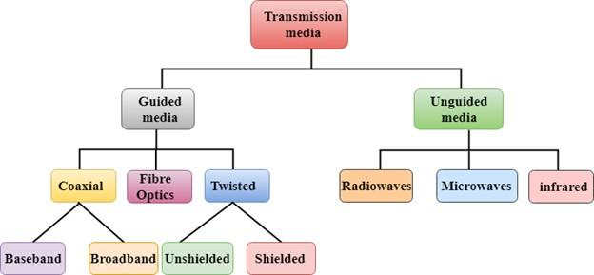
1.Twisted Pair Cable :
A twisted-pair cabling system is a cable consisting of one or several pairs of copper wires. These wires are twisted together and around each other and are insulated with a dielectric polymeric compound. Twisting helps minimize electromagnetic radiation and resists external interference.
A twisted pair cable is a type of cable made by putting two separate insulated wires together in a twisted pattern and running them parallel to each other. This type of cable is widely used in different kinds of data and voice infrastructures.

Twisted pair is of two types:
1.Shielded Twisted Pair(STP)
2.Unshielded Twisted Pair(UTP)
Shielded Twisted Pair:
Shielded Twisted Pair (STP) cables additionally have an overall conducting metallic shields
covering four twisted pair wires.
Advantage of Shielded Twisted Pair:
1.The cost of the shielded twisted pair cable is not very high and not very low.
2.An installation of STP is easy.
3.It has higher capacity as compared to unshielded twisted pair cable.
4.It has a higher attenuation.
5.It is shielded that provides the higher data transmission rate.
Disadvantages:
1.It is more expensive as compared to UTP and coaxial cable.
2.It has a higher attenuation rate.

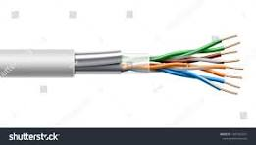

2.Coaxial Cable: Coaxial cable is a type of copper cable specially built with a metal shield and other components engineered to block signal interference. Coaxial cable (or coax) carries signals of higher frequency ranges than those in twisted pair cable. It has a central core conductor of solid or stranded wire (usually copper) enclosed in an insulating sheath, which is, in turn, encased in an outer conductor of metal foil, braid, or a combination of the two. The outer conductor is also enclosed in an insulating sheath, and the
whole cable is protected by a plastic cover.

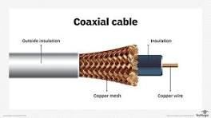

3. Fibre Optic Cable:
A fiber optic cable is a network cable that contains strands of glass fibers inside an insulated casing. They're designed for long-distance, high-performance data networking, and telecommunications. Compared to wired cables, fiber optic cables provide higher bandwidth and transmit data over longer distances. Fiber optic cables support much of the world's internet, cable television, and telephone systems.
Advantages of Fiber Optic Cables:
1.The loss ofsignal in optical fiber is less than that in copper wire.
2.Opticalfibers usually have a longer life cycle for over 100 years.
Disadvantage:
1.It is expensive.
2.Difficult to install.
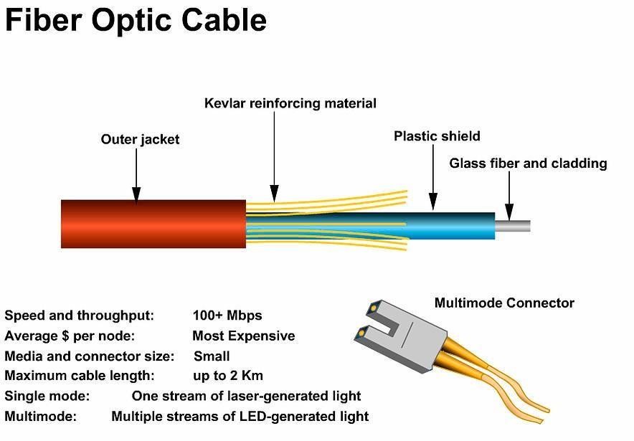

Types of unguided Transmission media:
- Radio Transmission:
- Microwaves:
- Infrared:

4. Connectors:
A device that terminates a segment of cabling or provides a point of entry for networking devices such as computers, hubs, and routers. Connectors can be distinguished according to their physical appearance and mating properties, such as jacks and plugs (male connectors) or sockets and ports (female connectors).

